Lab Session 10

String Handling Instructions

Primitive String Instructions

- The x86 instruction set has five groups of instructions for processing arrays of bytes, words, and double words.

- Each instruction implicitly uses ESI, EDI, or both registers to address memory.

- References to the accumulator imply the use of AL, AX, or EAX, depending on the instruction data size. String primitives execute efficiently because they automatically repeat and increment array indexes.
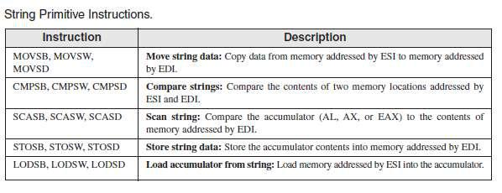

1. MOVSB, MOVSW, and MOVSD

The MOVSB, MOVSW, and MOVSD instructions copy data from the memory location pointed to by ESI to the memory location pointed to by EDI. The two registers are either incremented or decremented automatically (based on the value of the Direction flag):
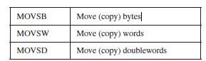

Using a Repeat Prefix

By itself, a string primitive instruction processes only a single memory value or pair of values. If you add a repeat prefix, the instruction repeats, using ECX as a counter. The repeat prefix permits you to process an entire array using a single instruction. The following repeat prefixes are used:
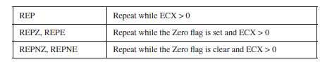

Example: Copy a String

In the following example, MOVSB moves 10 bytes from string1 to string2. The repeat prefix first tests ECX > 0 before executing the MOVSB instruction. If ECX = 0, the instruction is ignored and control passes to the next line in the program. If ECX > 0, ECX is decremented and the instruction repeats:

INCLUDE Irvine32.inc
.data

string1 BYTE 'this is first string',0 string2 BYTE 'this is second string',0

.code

main PROC
cld ; clear direction flag

mov esi,OFFSET string1 ; ESI points to source
mov edi,OFFSET string2 ; EDI points to target
mov ecx,sizeof string1 ; set counter to 10

rep movsb ; move bytes
mov edx,offset string2
call writestring

main ENDP
END main

ESI and EDI are automatically incremented when MOVSB repeats. This behavior is controlled by the CPU’s Direction flag.

Direction Flag

String primitive instructions increment or decrement ESI and EDI based on the state of the Direction flag. The Direction flag can be explicitly modified using the CLD and STD instructions:

CLD | ; | clear Direction flag (forward direction)
STD | ; | set Direction flag (reverse direction)
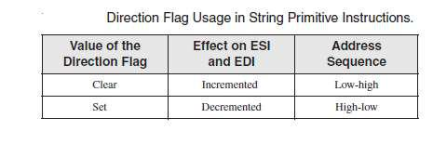
EL-213 Computer Organization and Assembly Language

2. CMPSB, CMPSW, and CMPSD

The CMPSB, CMPSW, and CMPSD instructions each compare a memory operand pointed to by ESI to a memory operand pointed to by EDI: You can use a repeat prefix with CMPSB, CMPSW, and CMPSD. The Direction flag determines the incrementing or decrementing of ESI and EDI.
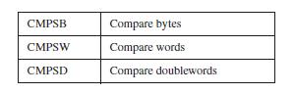

Example: Comparing Doublewords

Suppose you want to compare a pair of double words using CMPSD. In the following example, source has a smaller value than target , so the JA instruction will not jump to label L1.

INCLUDE Irvine32.inc
.data

greater BYTE 'source > target',0 lessOrEqual BYTE 'source <target',0 source BYTE 'abcd',0
target BYTE 'abc',0

.code
main PROC
mov esi,OFFSET source
mov edi,OFFSET target
cmpsd | ; compare doublewords
ja L1 | ; jump if source > target
mov edx,offset lessOrEqual | ;else print source <= target
call writestring
jmp endd
L1:
mov edx,offset greater
call writestring
endd:
exit
main ENDP
END main

3. SCASB, SCASW, and SCASD

The SCASB, SCASW, and SCASD instructions compare a value in AL/AX/EAX to a byte, word, or double word, respectively, addressed by EDI. The instructions are useful when looking for a single value in a string or array. Combined with the REPE (or REPZ) prefix, the string or array is scanned while ECX > 0 and the value in AL/ AX/ EAX match each subsequent value in memory. The REPNE prefix scans until either AL/AX/EAX matches a value in memory or ECX = 0.
EL-213 Computer Organization and Assembly Language

Scan for a Matching Character

In the following example we search the string alpha, looking for the letter F. If the letter is found, EDI points one position beyond the matching character. If the letter is not found, JNZ exits:

.data
alpha BYTE "ABCDEFGH",0
.code
mov edi,OFFSET alpha | ; EDI points to the string
mov al,'F' | ; search for the letter F
mov ecx,LENGTHOF alpha | ; set the search count
cld | ; direction = forward
repne scasb | ; repeat while not equal
jnz quit | ; quit if letter not found
dec edi | ; found: back up EDI

JNZ was added after the loop to test for the possibility that the loop stopped because ECX = 0 and the character in AL was not found.

4. STOSB, STOSW, and STOSD

The STOSB, STOSW, and STOSD instructions store the contents of AL/AX/EAX, respectively, in memory at the offset pointed to by EDI. EDI is incremented or decremented based on the state of the Direction flag. When used with the REP prefix, these instructions are useful for filling all elements of a string or array with a single value. For example, the following code initializes each byte in string1 to 0FFh:

.data
Count = 100
string1 BYTE Count DUP(?)
.code
mov al,0FFh | ; value to be stored
mov edi,OFFSET string1 | ; EDI points to target
mov ecx,Count | ; character count
cld | ; direction = forward
rep stosb | ; fill with contents of AL

5. LODSB, LODSW, and LODSD

The LODSB, LODSW, and LODSD instructions load a byte or word from memory at ESI into AL/AX/EAX, respectively. ESI is incremented or decremented based on the state of the Direction flag. The REP prefix is rarely used with LODS because each new value loaded into the accumulator overwrites its previous contents. Instead, LODS is used to load a single value. In the next example, LODSB substitutes for the following two instructions (assuming the Direction flag is clear):

mov al,[esi] ; move byte into inc esi ; point to next byte
EL-213 Computer Organization and Assembly Language

Array Multiplication:

The following program multiplies each element of a doubleword array by a constant value. LODSD and STOSD work together:

TITLE Multiply an Array (Mult.asm)
- This program multiplies each element of an array

- of 32-bit integers by a constant value.
INCLUDE Irvine32.inc
.data
array DWORD 1,2,3,4,5,6,7,8,9,10 | ; test data
multiplier DWORD 10 | ; test data
.code
main PROC
cld | ; direction = forward
mov esi,OFFSET array | ; source index
mov edi,esi | ; destination index
mov ecx,LENGTHOF array | ; loop counter
L1:
lodsd | ; load [ESI] into EAX
mul multiplier | ; multiply by a value
stosd | ; store EAX into [EDI]
loop L1
exit
main ENDP
END main

String Procedures

1. STR_CPY
The Str_copy procedure copies a null-terminated string from a source location to a target location.

Syntax: INVOKE Str_copy, ADDR source, ADDR target

2. STR_LENGTH
The Str_length procedure returns the length of a string in the EAX register. When you call it, pass the string’s offset.

Syntax: INVOKE Str_length, ADDR myString

3. STR_COMPARE
The Str_compare procedure compares two strings. It affects the CF and ZF as shown in the following table.

Syntax: INVOKE Str_compare, ADDR string1, ADDR string2

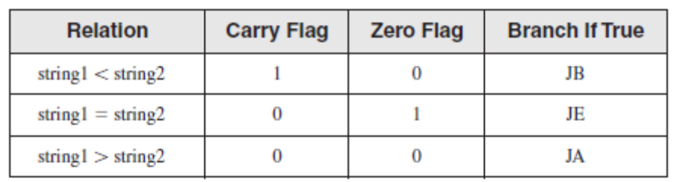

Exercise

- Create a procedure named Scan_String to find the index of the first occurrence of the character ‘#’ in the given string.

Str1 BYTE ‘127&j~3#^&*#*#45^’,0

- Modify the above procedure to take offset of string1 and the character to be searched as argument.
- Create IsCompare procedure to compare two strings.

- Write the procedure to get_frequency Find the frequency of characters:
.data
target BYTE "AAEBDCFBBC",0
freqTable DWORD 256 DUP(0)
.code
INVOKE Get_frequencies, ADDR target, ADDR freqTable

